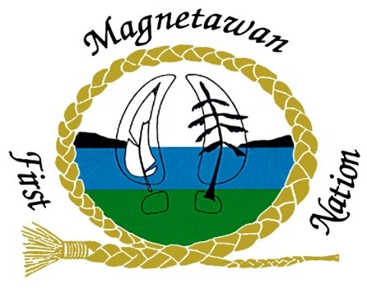

EMPLOYMENT OPORTUNITY

Receptionist

Closing Date November 18th, 2022
Salary Range To be discussed upon hire
Job Classification Full Time, 35 hours per week
Qualifications Excellent computer skills
Excellent interpersonal and communication skills
Excellent customer service skills

The Magnetawan First Nation is seeking an energetic individual who enjoys working with and helping the public to fill the position of Receptionist for the band office.

- Duties and Responsibilities

- Provide office support services in order to ensure efficiency and effectiveness within the Band office
- Greet, assist and/or direct visitors and the general public
- Respond to public inquiries
- Answer all incoming calls and handle caller’s inquiries whenever possible
- Re-direct calls as appropriate and take adequate messages when required
- Direct the First Nation Members and the general public to the appropriate staff member
- Pick up and deliver the mail
- Open and date stamp all general correspondence
- Maintain the general filing system and file all correspondence
- Assist in the planning and preparation of meetings, conferences and conference telephone calls
- Provide word-processing and secretarial support
- Make preparations for Health Centre and committee meetings
- Monitor the use of supplies and equipment
- Maintain an adequate inventory of office supplies
- Coordinate the repair and maintenance of office equipment
- Assist staff as requested
- Perform other related duties as required
- Maintain Confidentiality

B. SPECIAL REQUIREMENTS

- Confidentiality: The incumbent must maintain strict confidentiality in performing the duties. The incumbent must adhere to the Magnetawan First Nation Personnel Policy.

- Travel: On occasion, some travel may be required.

- Training: The incumbent must be willing to participate in professional training/conferences to develop and maintain knowledge, skills, and expertise necessary to achieve positive results.

- CPIC – A CPIC may be required to ensure the safety of Magnetawan First Nation and its members.

How to Apply
Interested applicants may apply, in confidence, by sending a cover letter, resume, photocopy of education diploma by fax, mail, hand deliver or email to,

Magnetawan First Nation
10 Regional Rd, Hwy 529
Britt, ON P0G 1A0
Fax: 705 383-2566
reception@magfn.com

